SCK 5V MISO

DC 3.3V GND

ICSP2

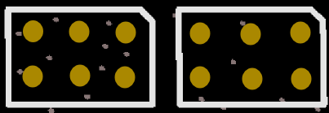

MOSI RESET GND

ICSP2

DD RST NC

ICSP1